CSA1010:-Software Engineering Evaluation Process

Name:G.Abi Charan

RegNo:192211048

1Q.DrawaUSE-CASEdiagramforOnlineVotingSystemusingCASE tools

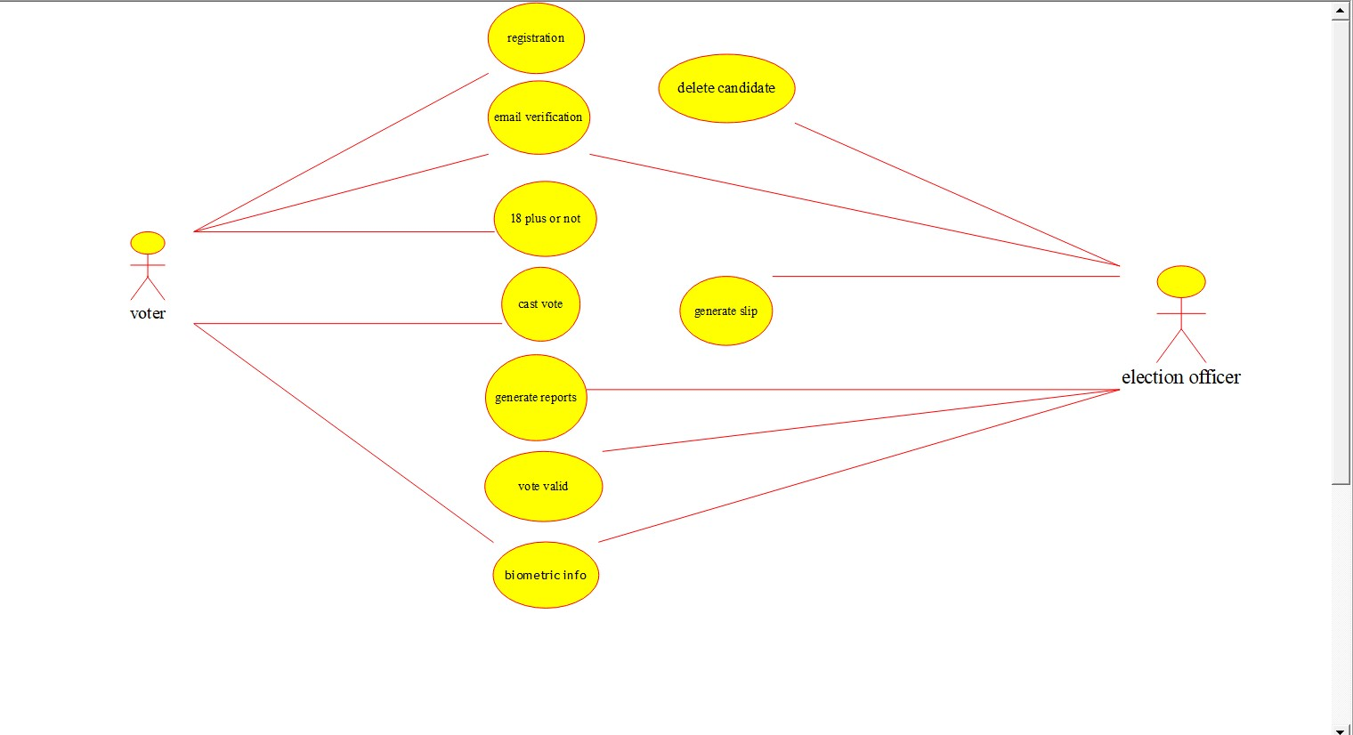

2Q.DrawaUSE-CASEdiagramforLibraryManagementSystemusing CASEtools.

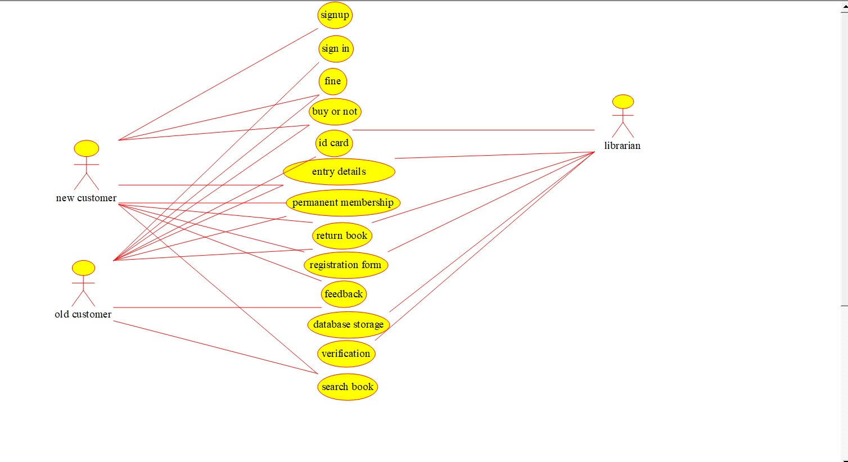

3Q.Drawandvalidatetheflowcharttocomputethequotientand remainder.

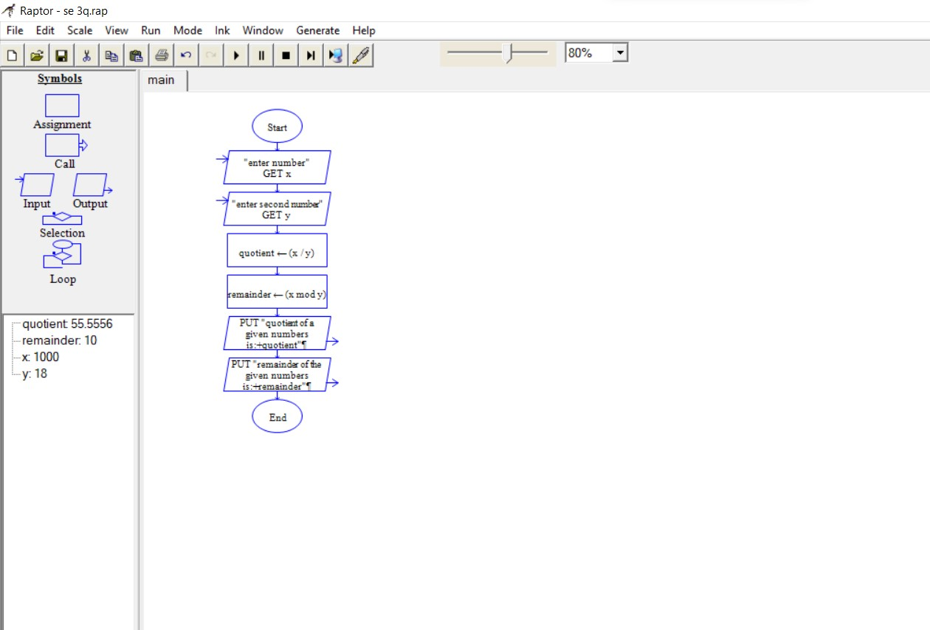

4Q.DrawaUSE-CASEdiagramforOnlineShoppingsystemusingCASE tools.

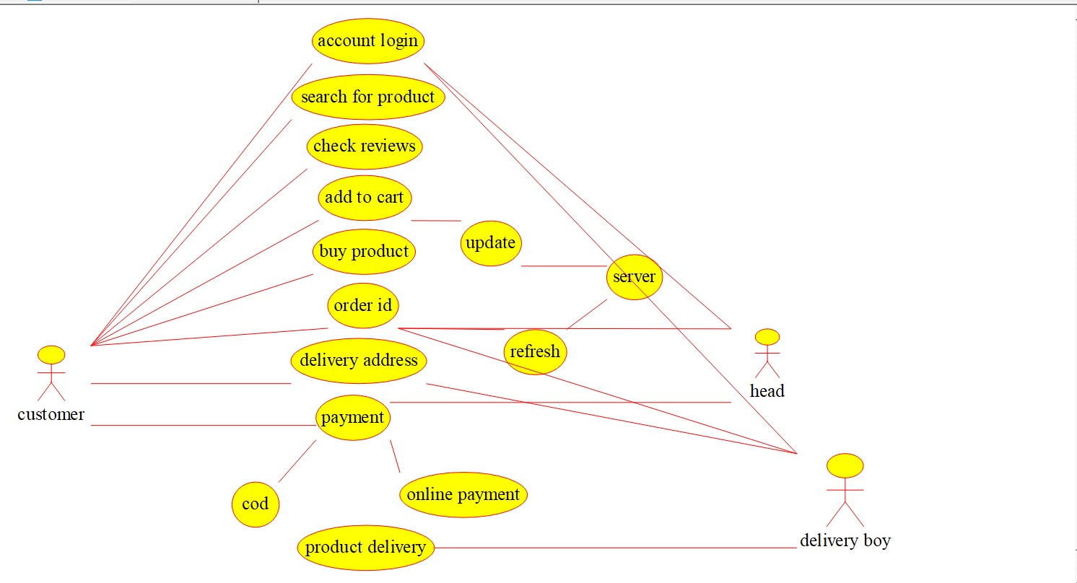

5Q.DrawaUSE-CASEdiagramforOnlineRailwayReservationSystem usingCASEtools.

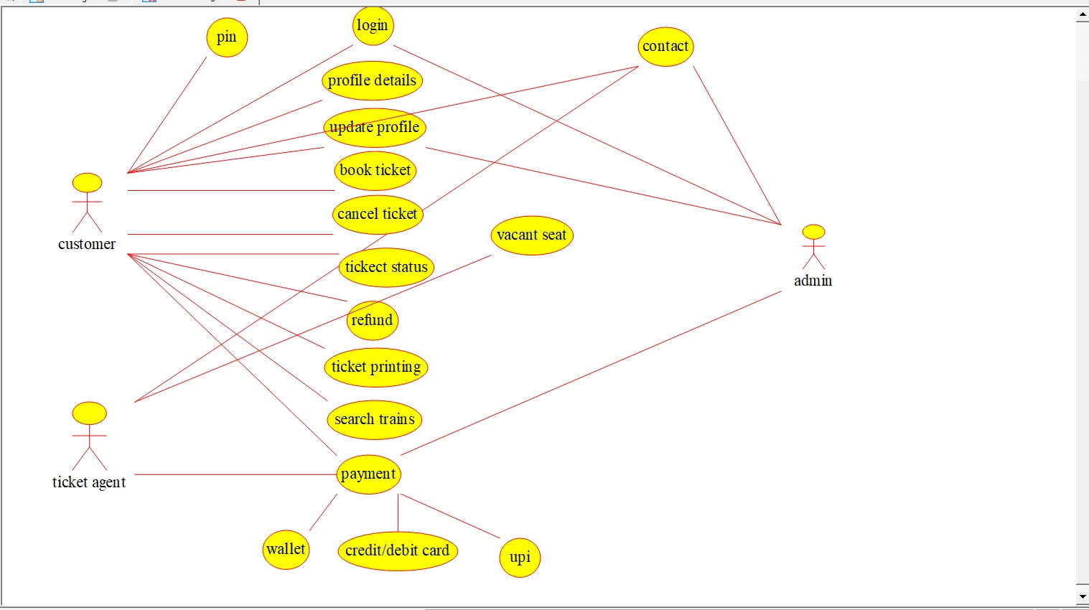

6Q.DrawaUSE-CASEdiagramforHospitalManagementSystemusing CASEtools.

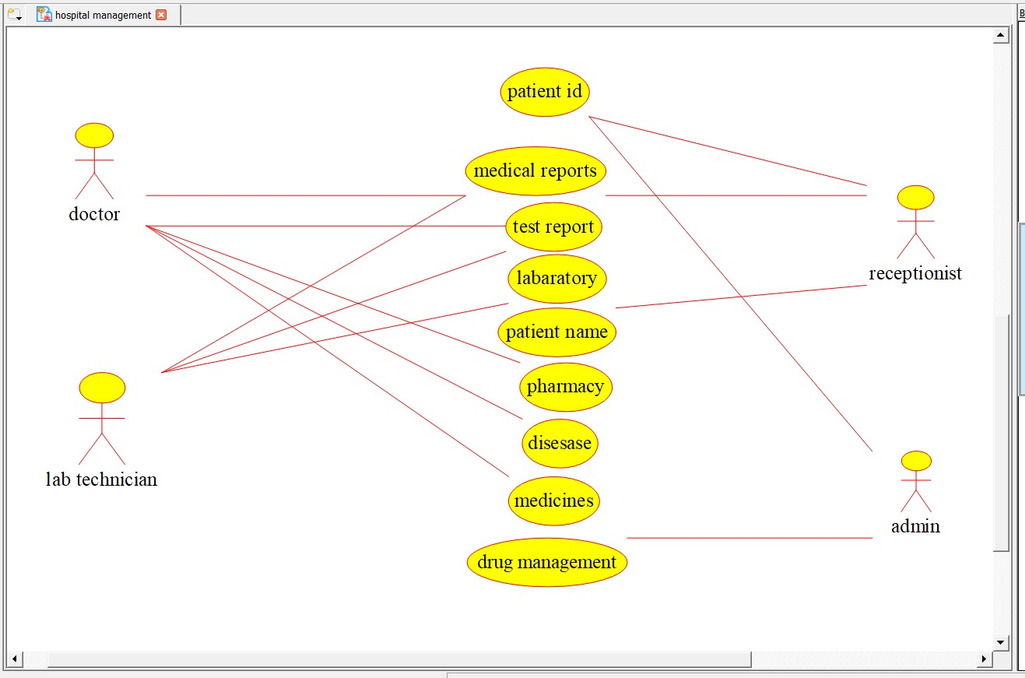

7Q.DrawaUSE-CASEdiagramforATMSystemusingCASEtools.

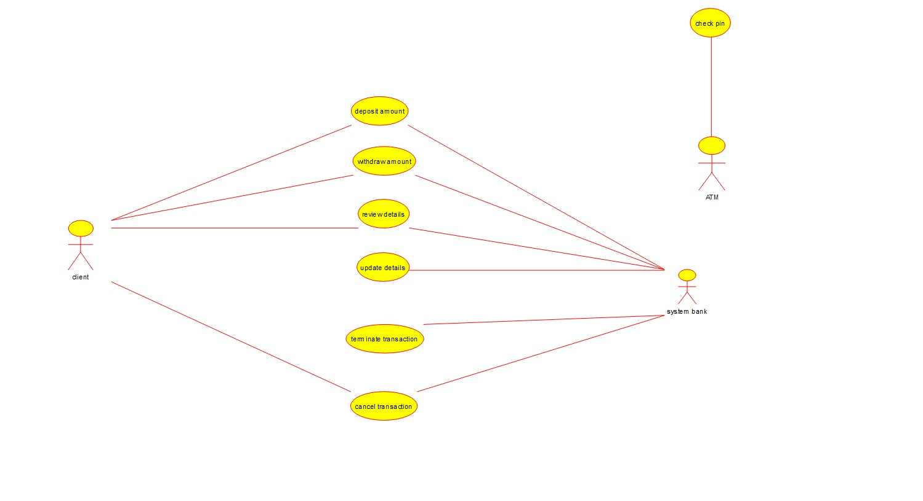

8Q.DrawaUSE-CASEdiagramforOnlinecollegemanagementSystem usingCASEtools.

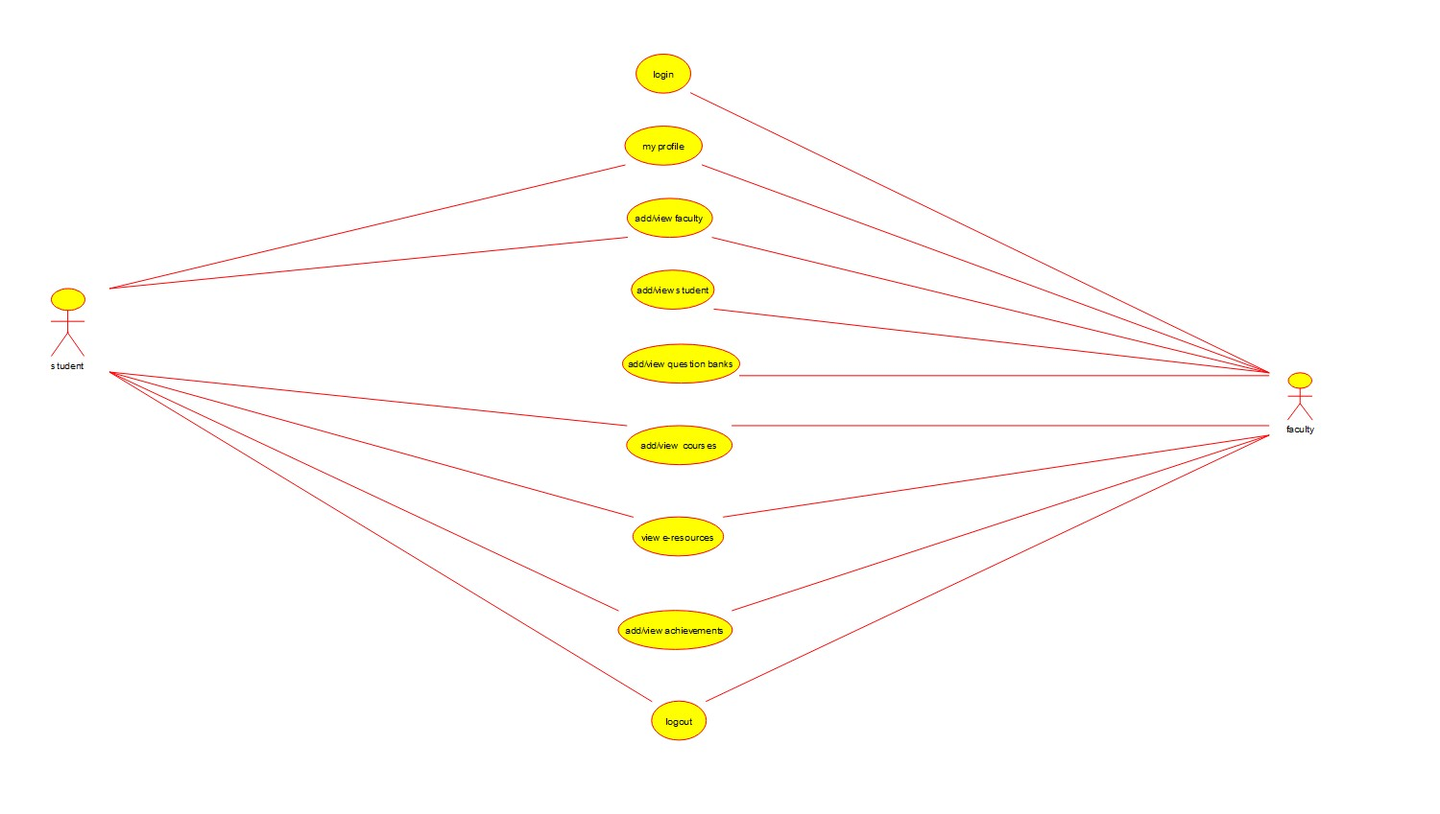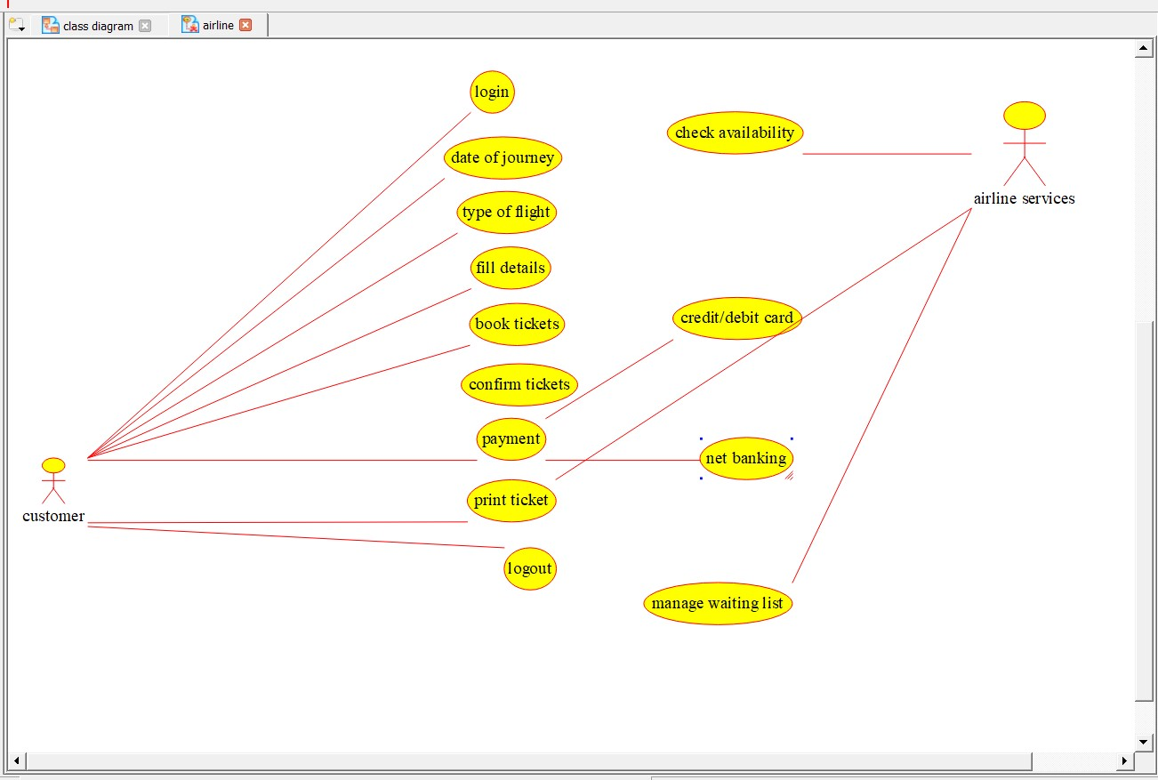

9Q.DrawaUSE-CASEdiagramforOnlineAirlineReservationSystem usingCASEtools.

10Q.DrawaClassdiagramforOnlineAirlineReservationSystemusing CASEtools.

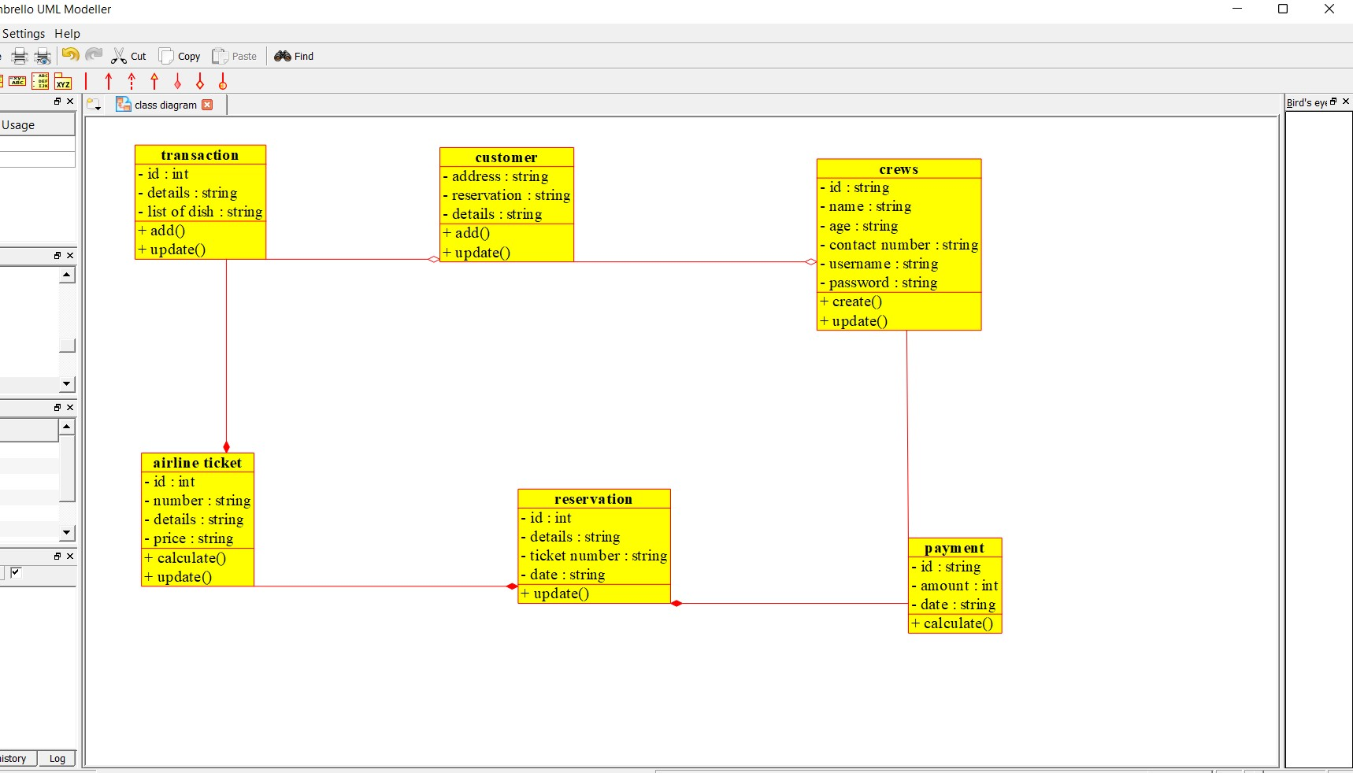

11Q.DrawaClassdiagramforOnlineVotingSystemusingCASEtools

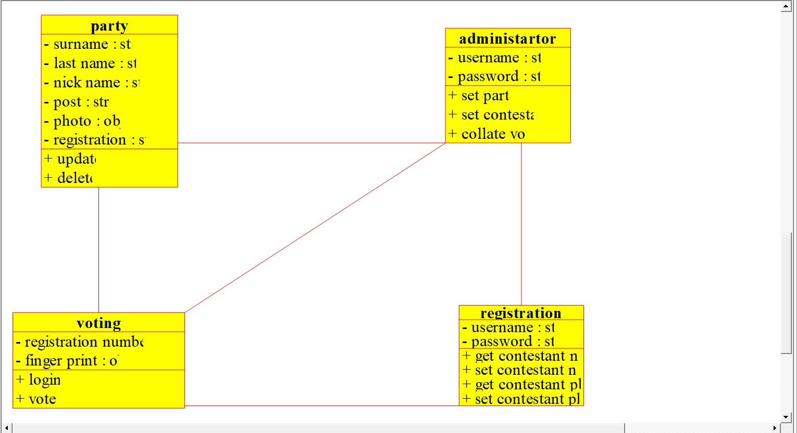

12Q.DrawaClassdiagramforLibraryManagementSystemusingCASE tools.

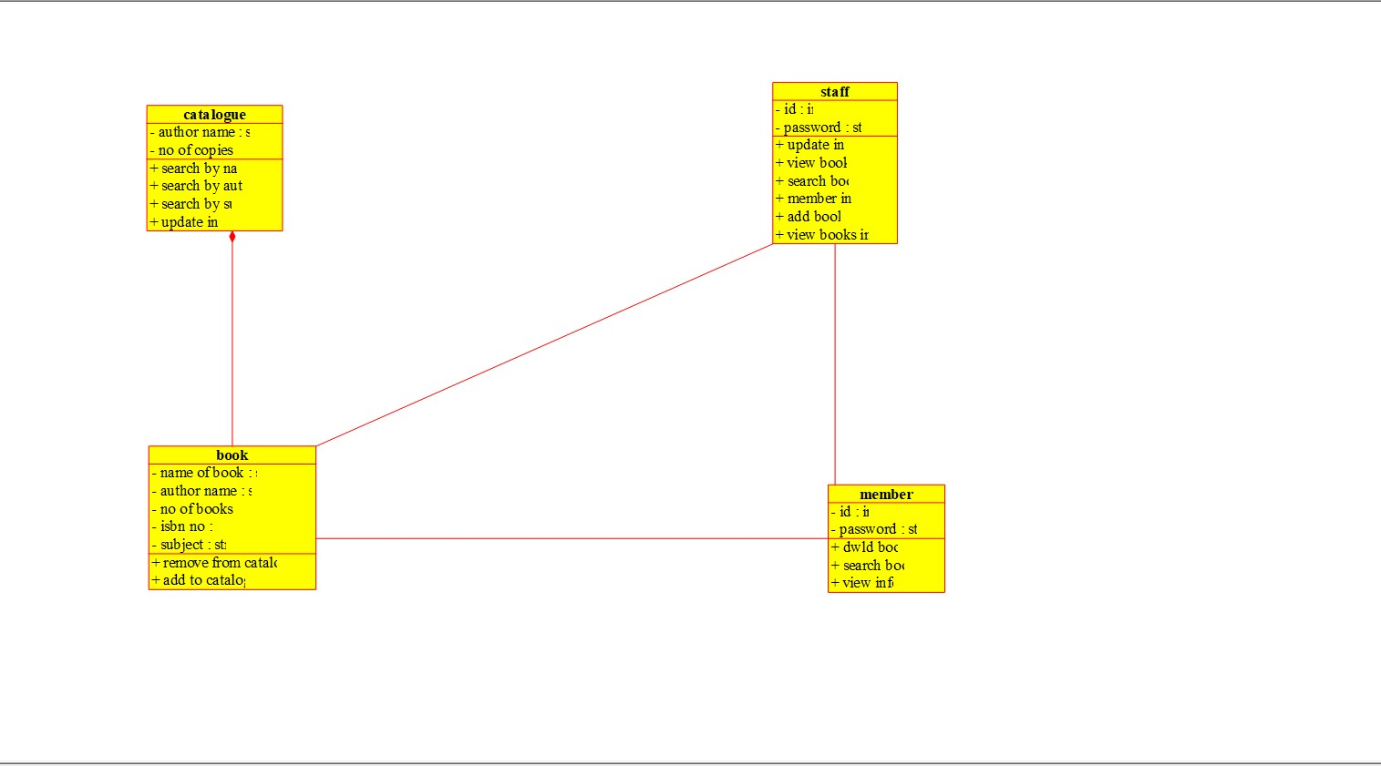

13Q.DrawaActivitydiagramforOnlineVotingSystemusingCASEtools.

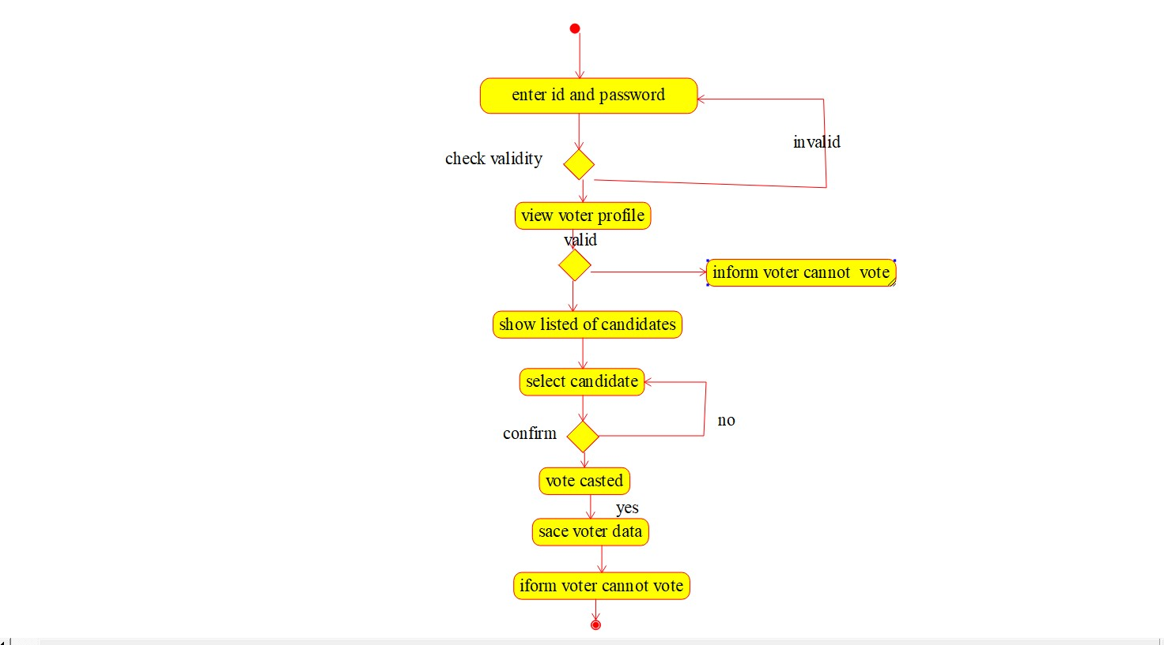

14Q.DrawaActivitydiagramforLibraryManagementSystemusing CASEtools.

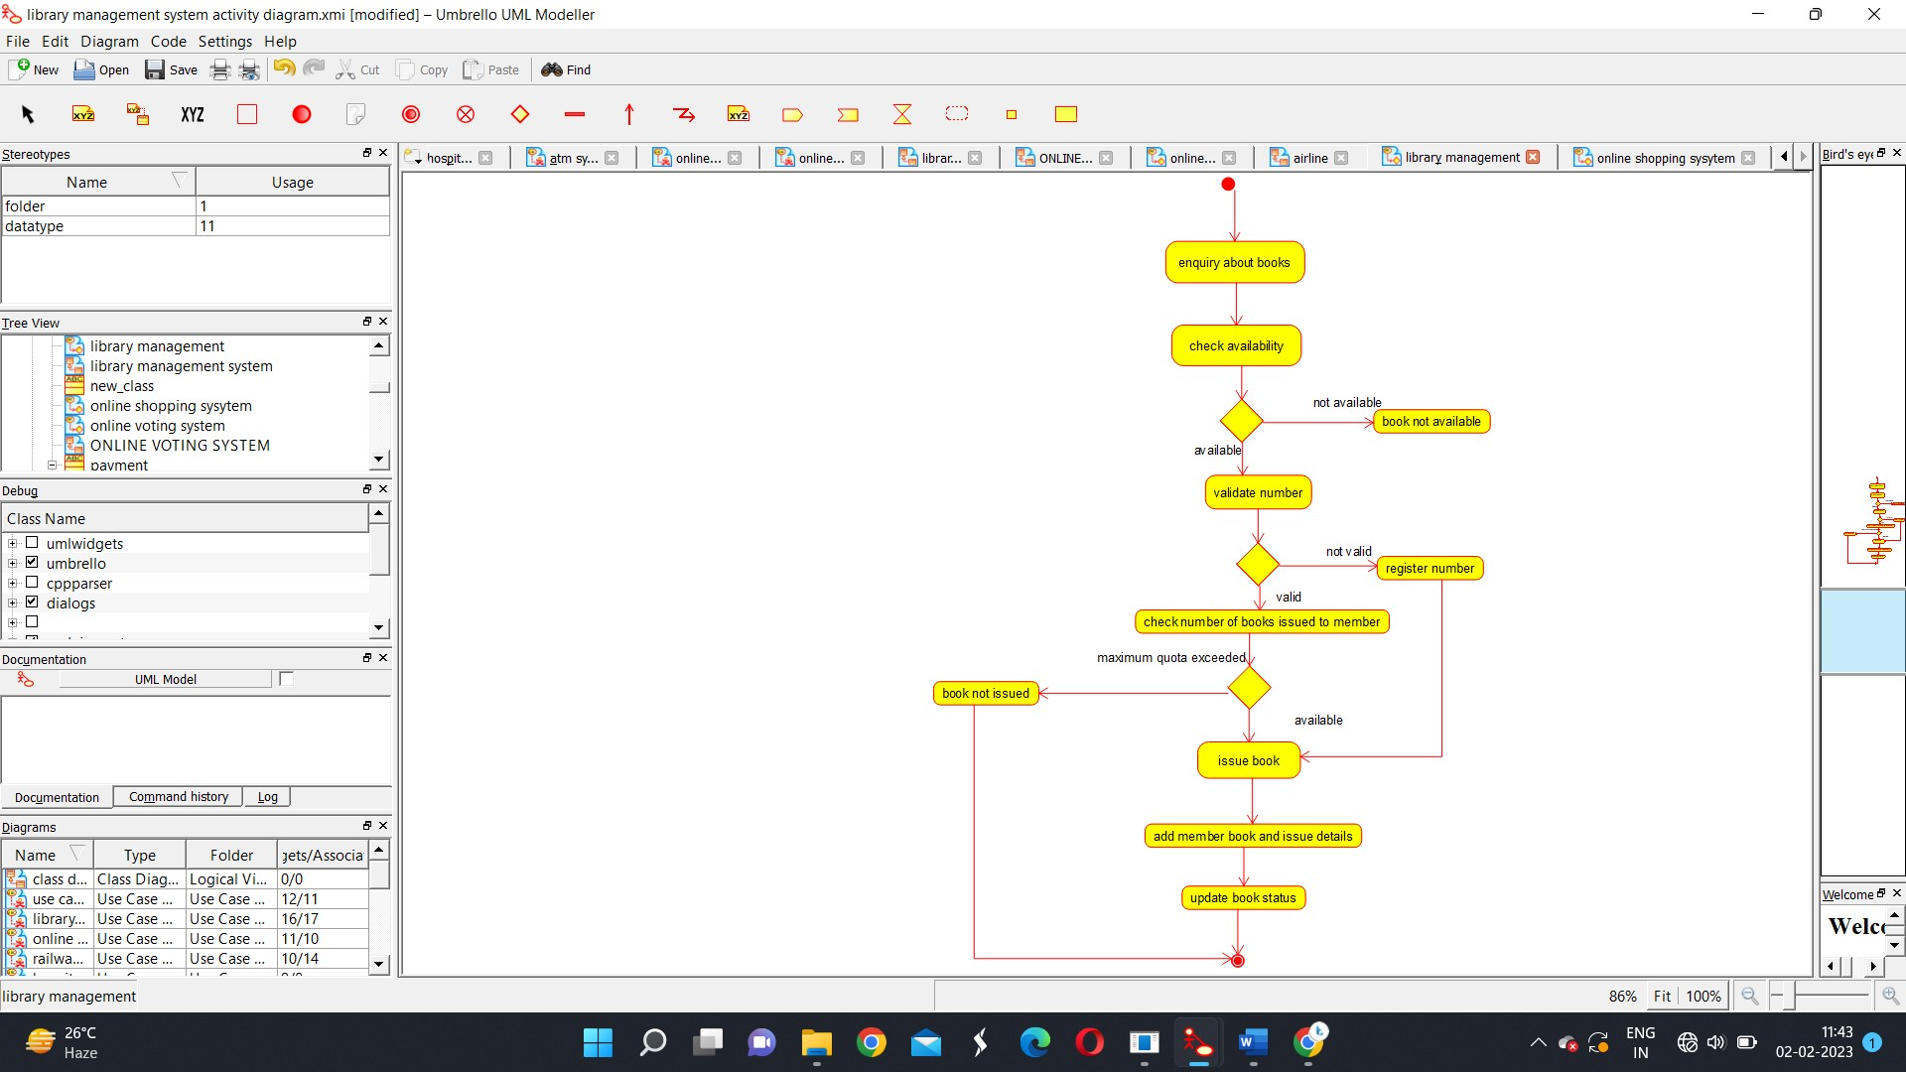

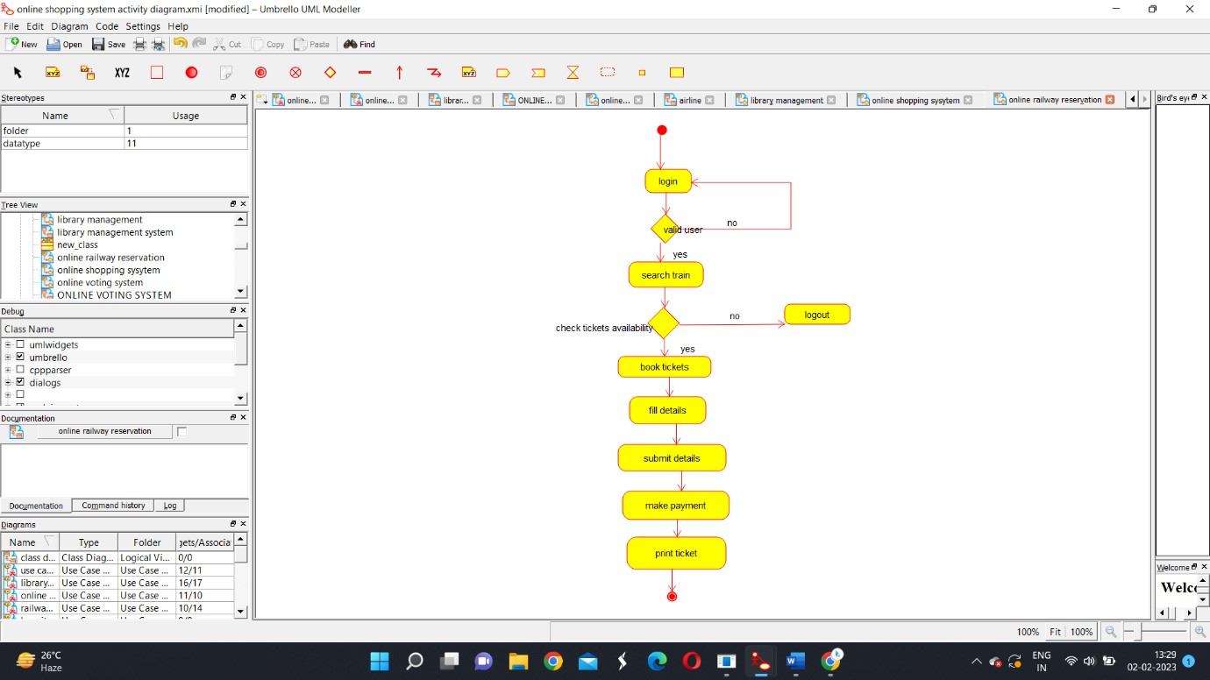15Q.DrawaActivitydiagramforOnlineShoppingsystemusingCASE tools.

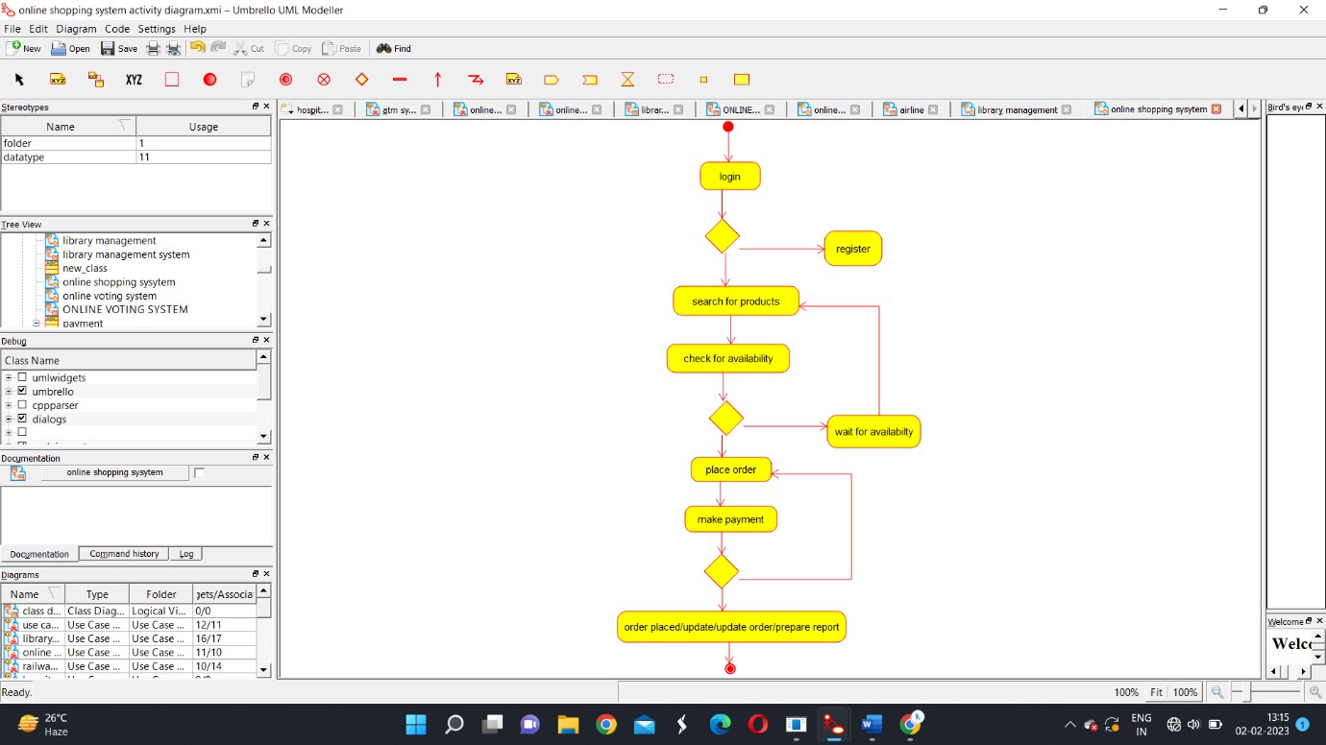

16Q.DrawaActivitydiagramforOnlineRailwayReservationSystem usingCASEtools. 17Q.DrawaActivitydiagramforHospitalManagementSystemusing CASEtools.

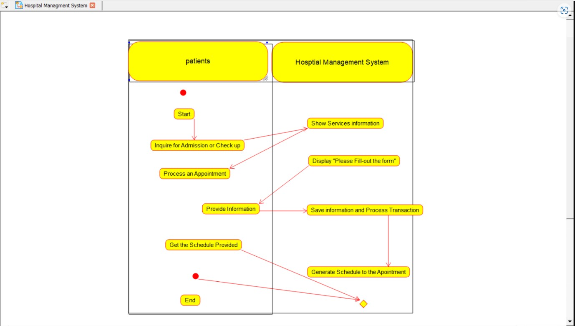

18Q.UsingRaptor-Drawtheflowcharttocheckwhetherthegiven numberisapalindromeornot.

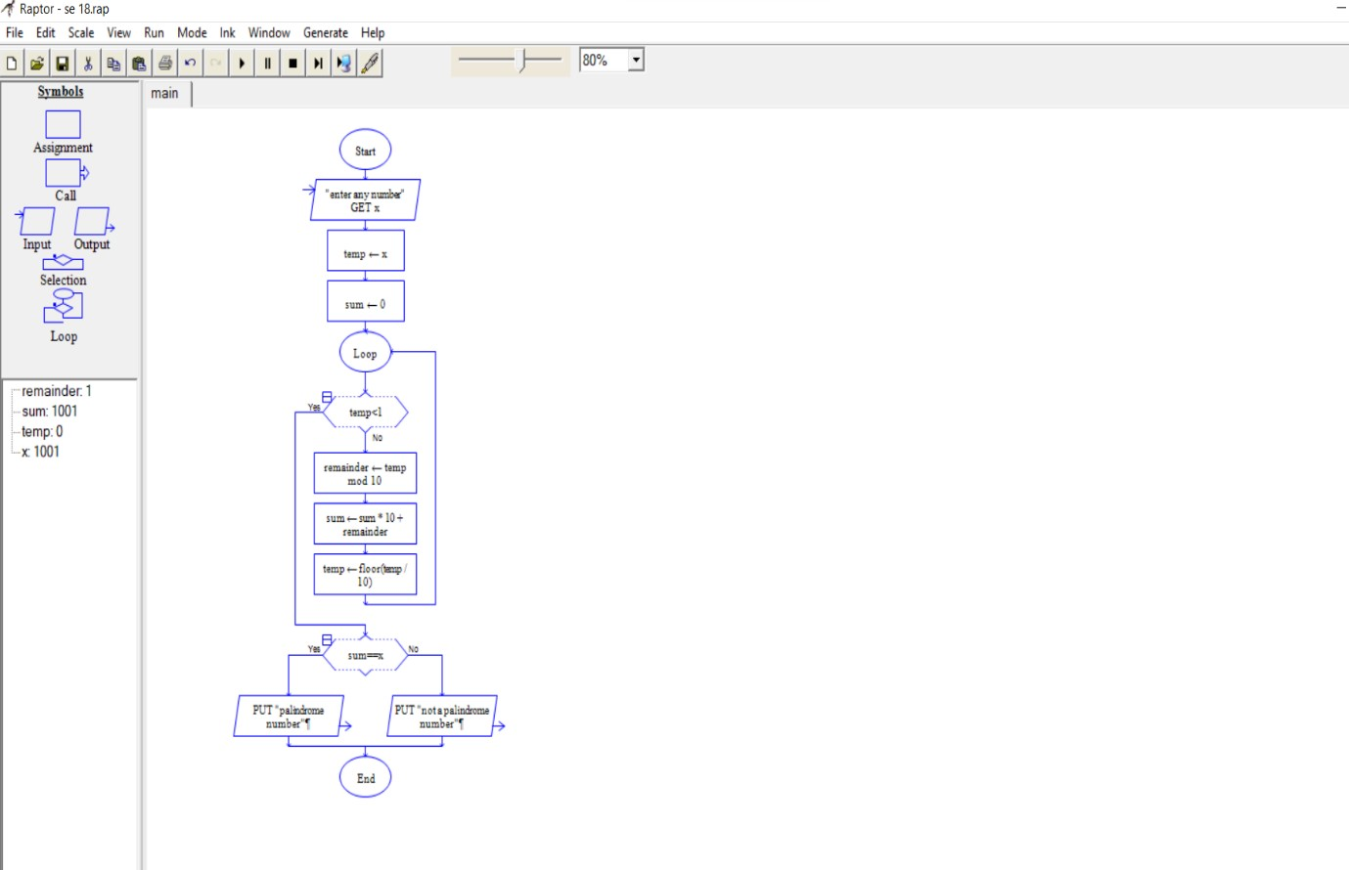

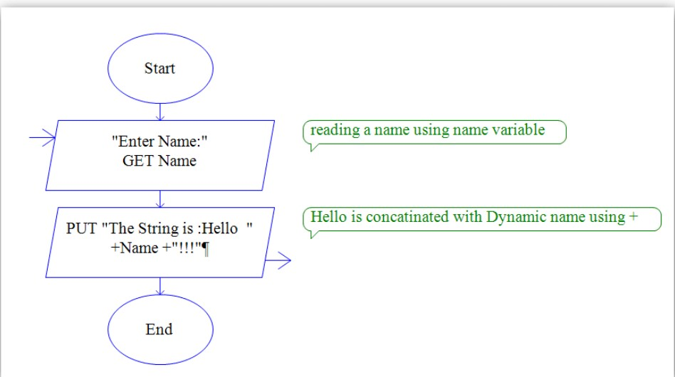19.UsingRaptor–Drawtheflowcharttoconvertlowercaselettersto uppercaseletters

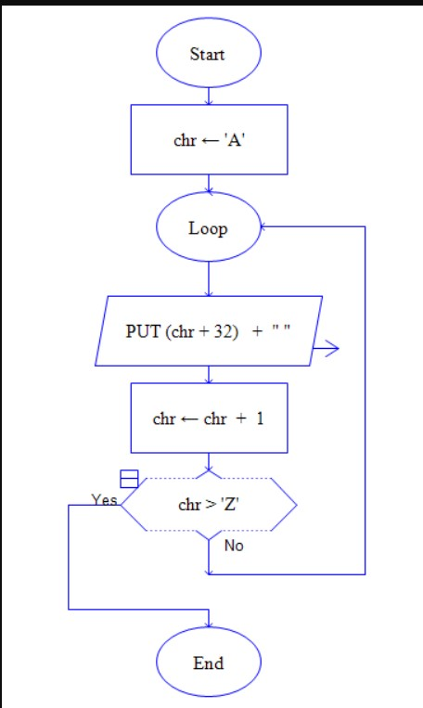

20.UsingRaptor–Drawtheflowcharttocounttotalnumberofstringsin agivenword

24Q.UsingRaptor-Drawtheflowcharttofindwhetherthegivennumberisprimeornot.

21Q.UsingRaptor-Drawtheflowcharttofindwhetherthegivennumber isprimeornot.

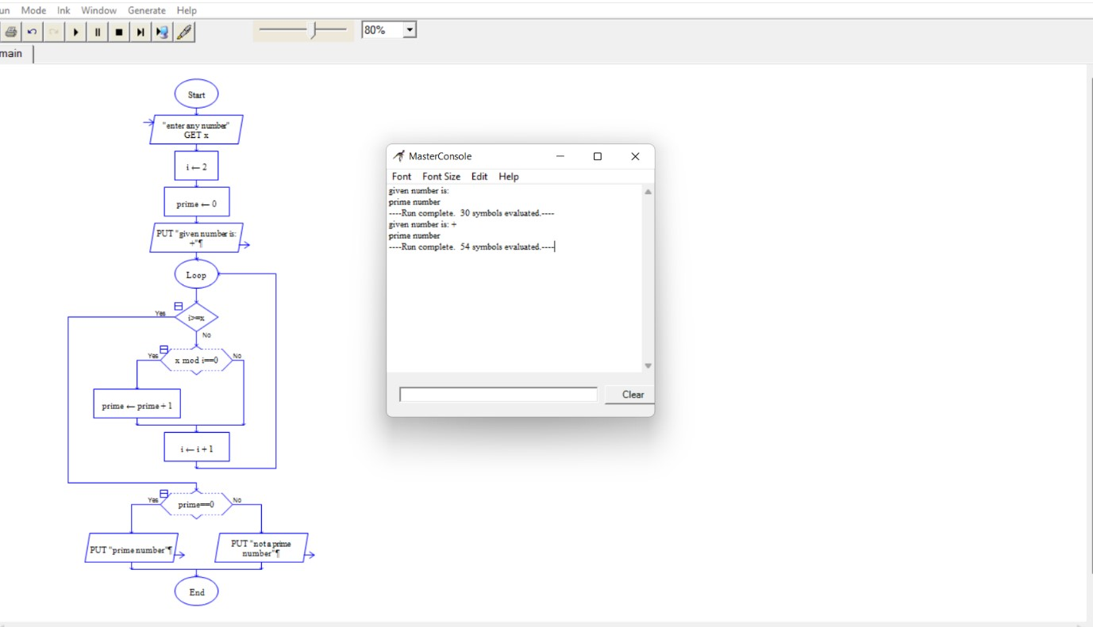

22Q.FindCyclomaticComplexityforagraphhavingnumberofedgesas

17,numberofnodesas13andnumberofpredicatenodesintheflow

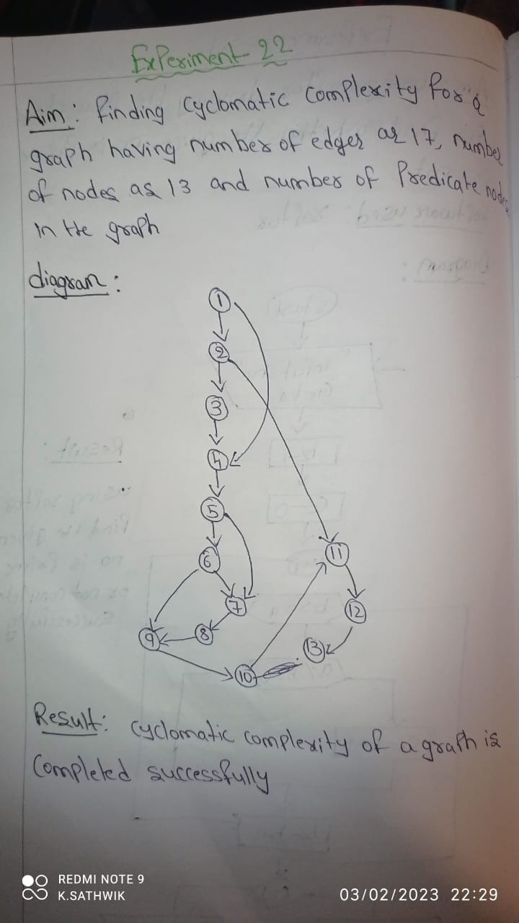

graphas5.

23.Designanactivitydiagramforanautomatedonlinebanking systemwhichshowstheflowofwithdrawal,depositandbalance enquiry.

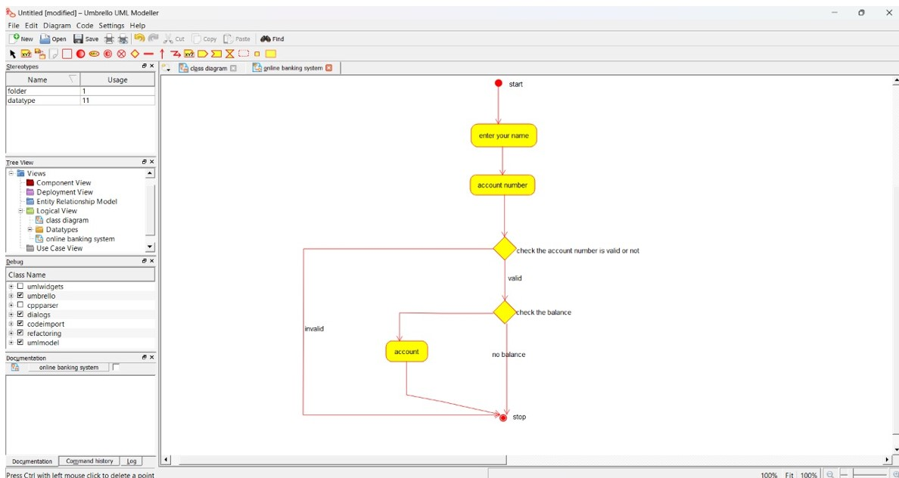

24.Developanactivitydiagramforane-libraryonlinepublicaccess catalogue



25.DrawaClassdiagramforane-libraryonlinepublicaccesscatalogue



26.DrawaUseCasediagramforaRestaurantSystems

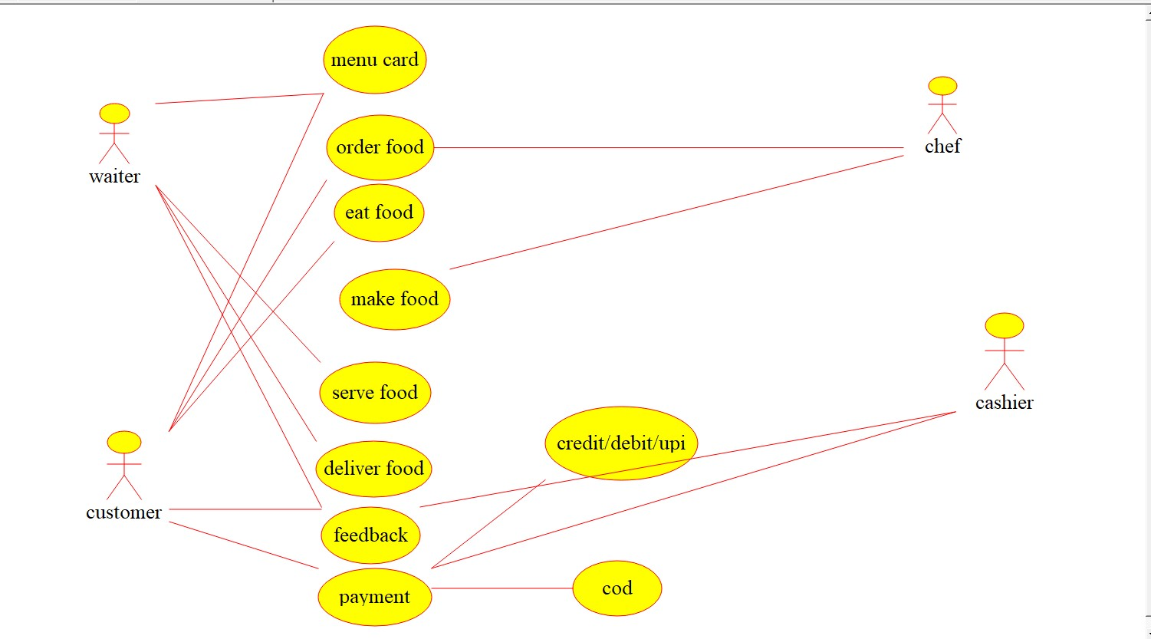

27.DrawaClassdiagramforaRestaurantSystems

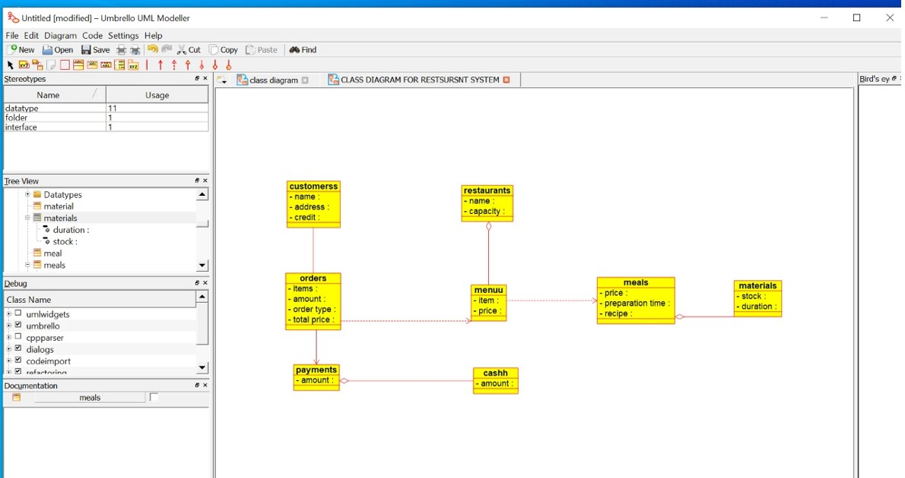

28.Makeaclassdiagramtomodelforaquizsystem

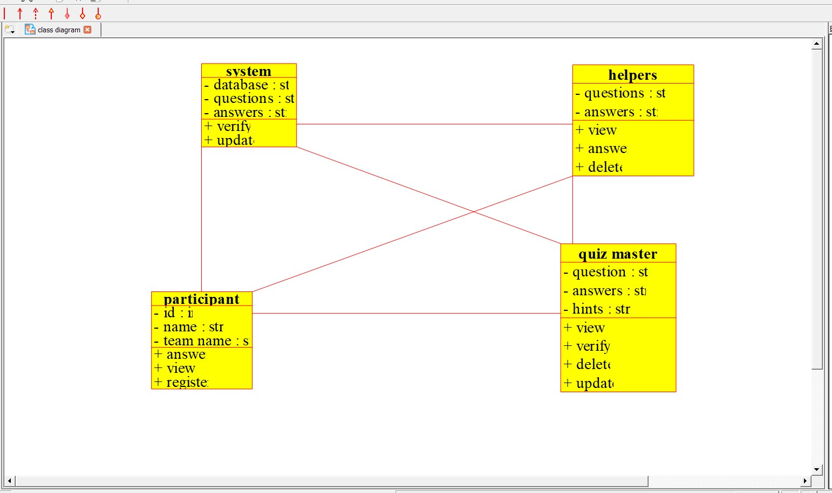

29.DrawaUsecasediagramtomodelforaquizsystem

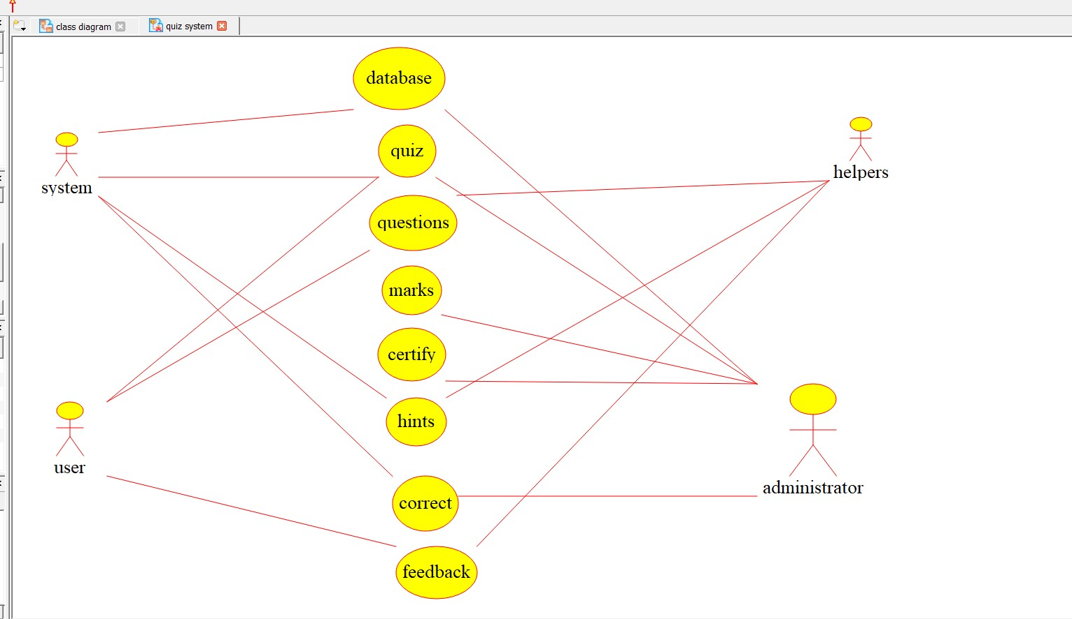

30.UsingRaptor-DrawandvalidatetheflowcharttocalculateFactorial ofanumber.

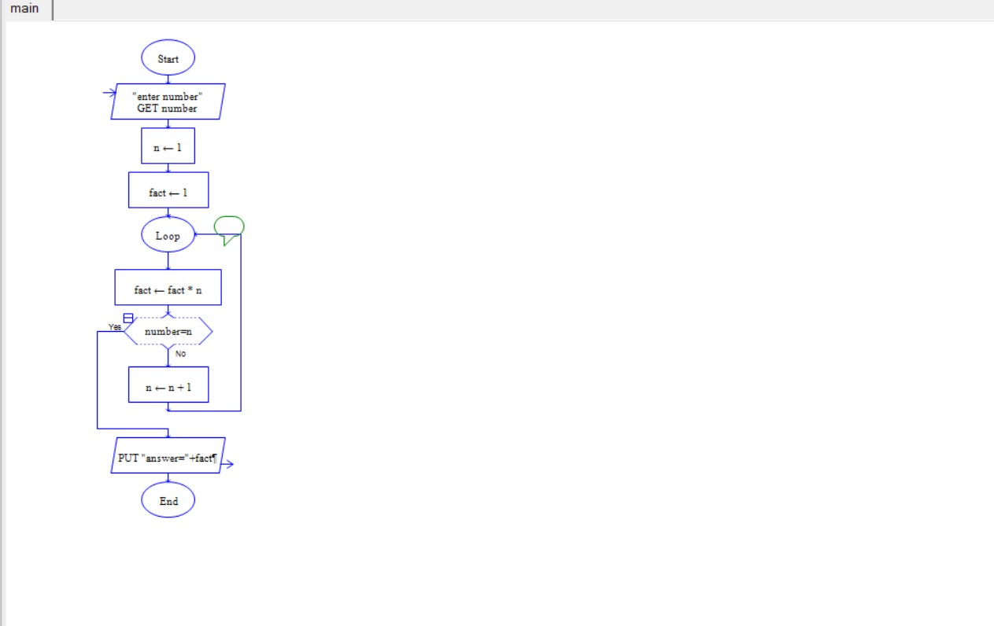

31.UsingRaptor–Drawandvalidatetheflowcharttofindoddseriesof thegivennumberandevenseriesuptoagivennumber

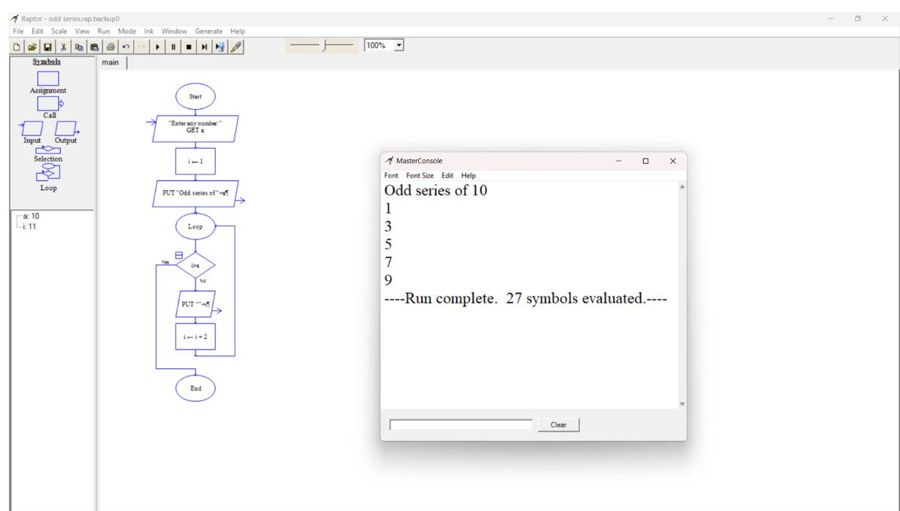

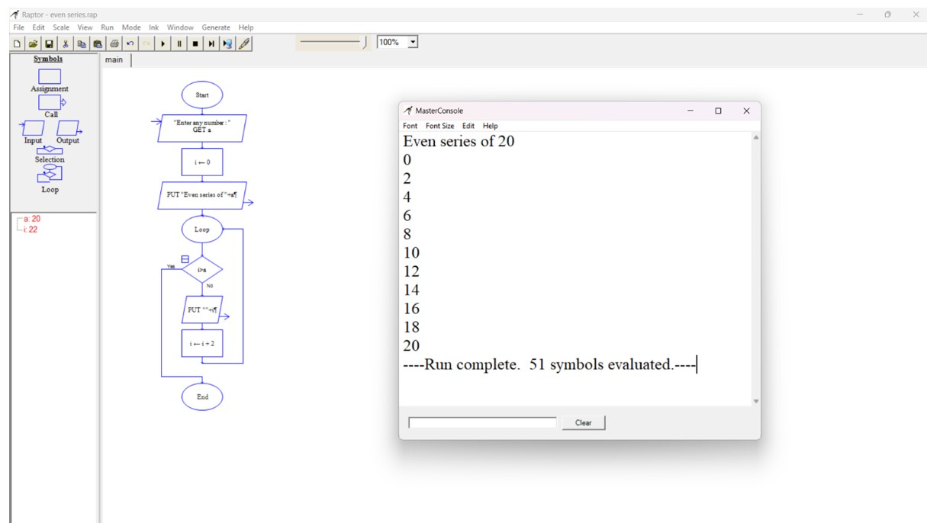

32.UsingRaptor–Drawtheflowcharttodisplaythereverseofthestring.

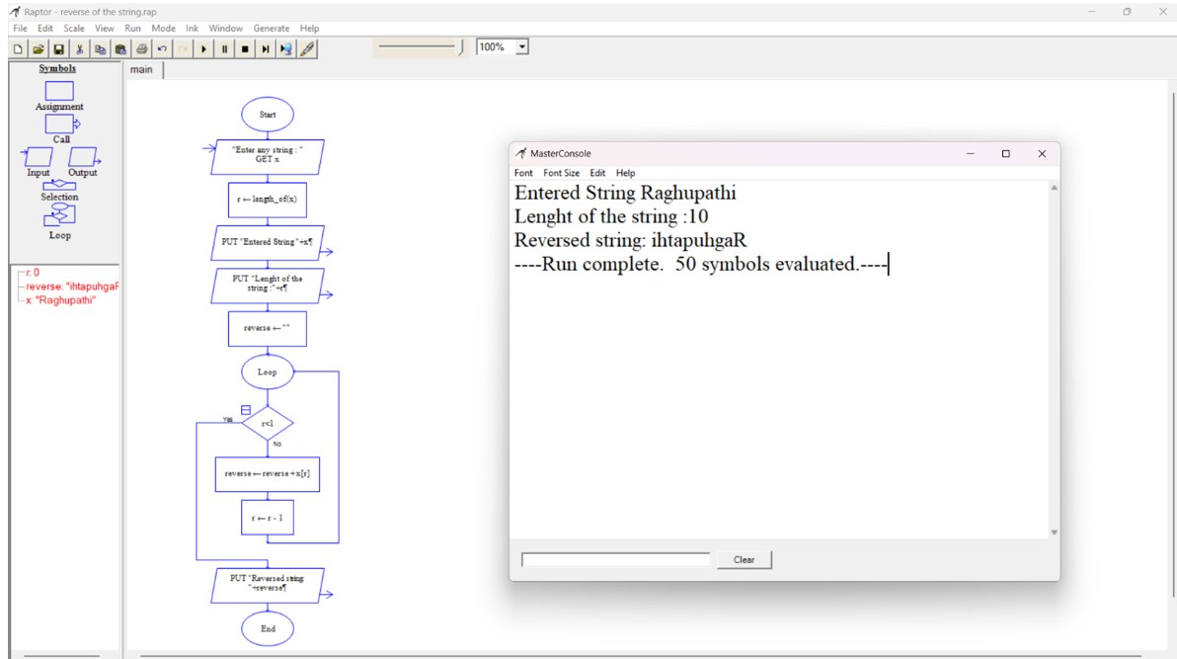

33.UsingRaptor–Drawtheflowcharttofindsumofnnumbers.

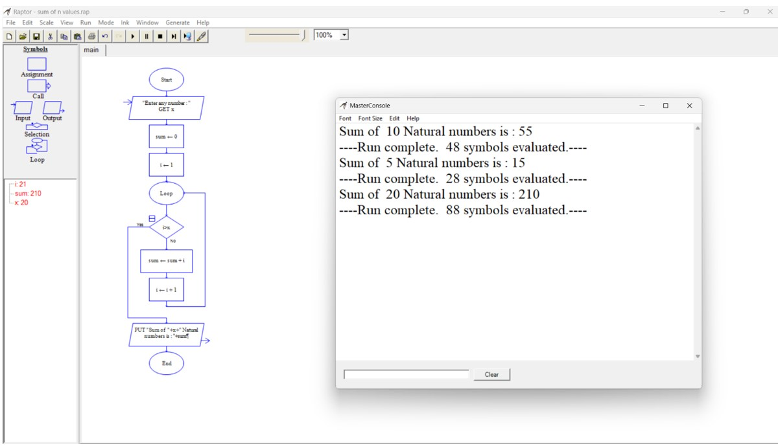

34.UsingRaptor–Drawtheflowcharttofindlargestofnnumbers.

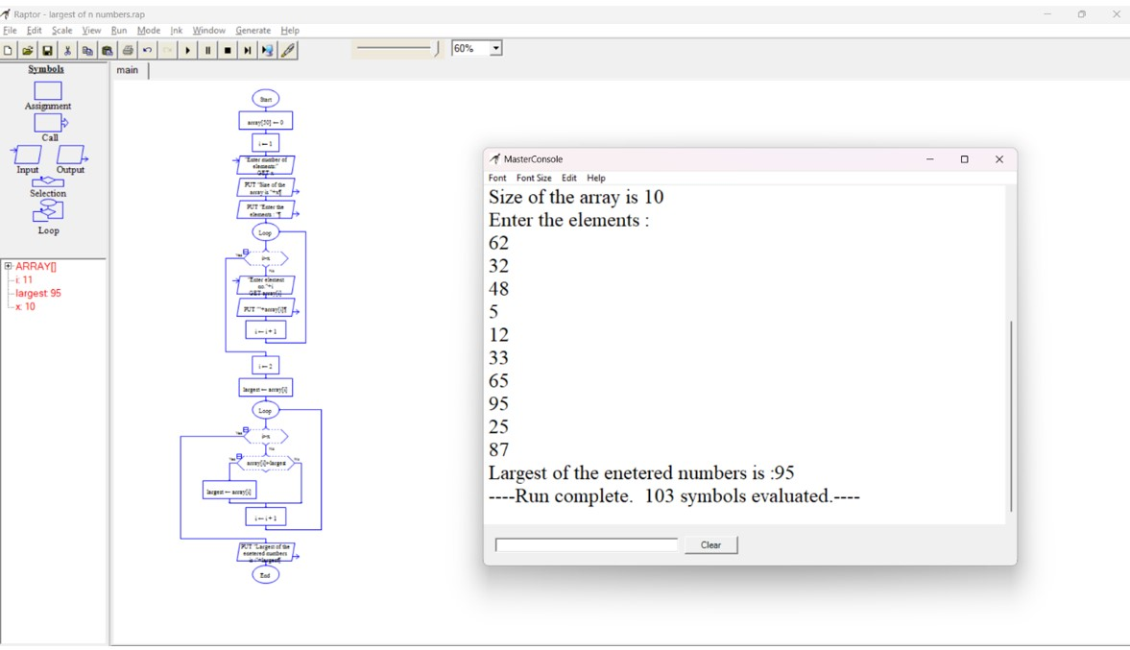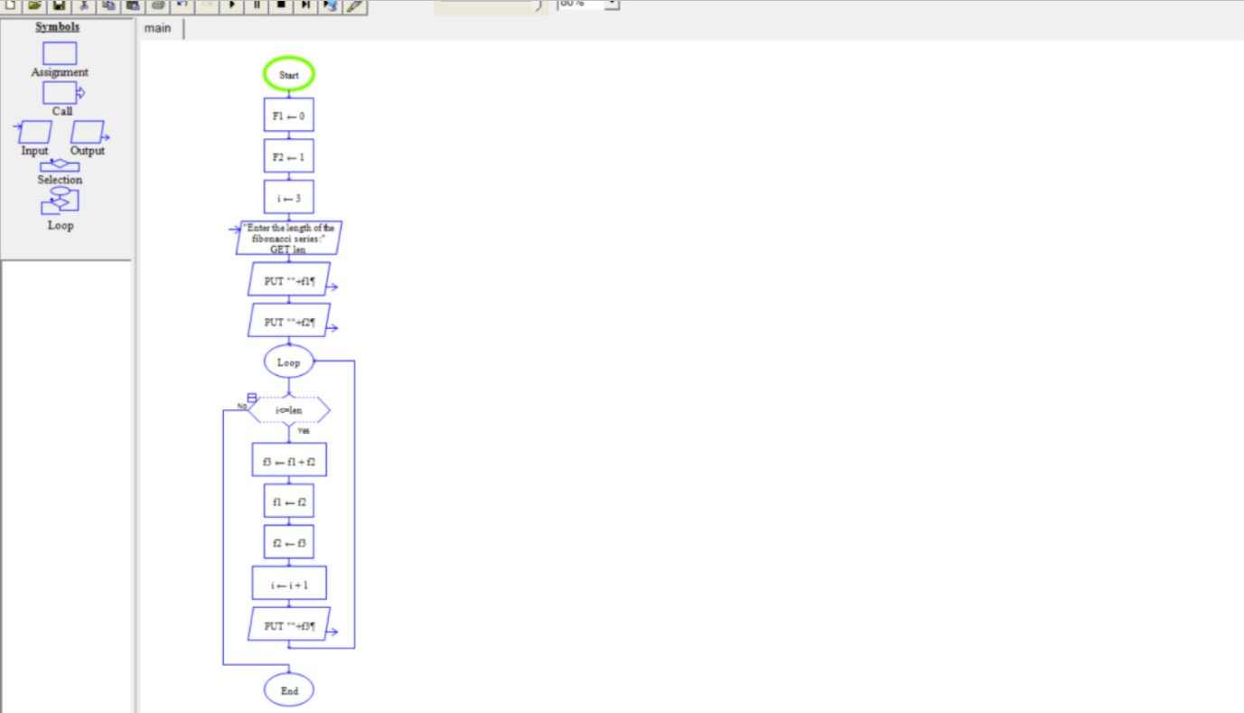

35Q.UsingRaptor-Drawandvalidatetheflowcharttocalculate Fibonacciseries.

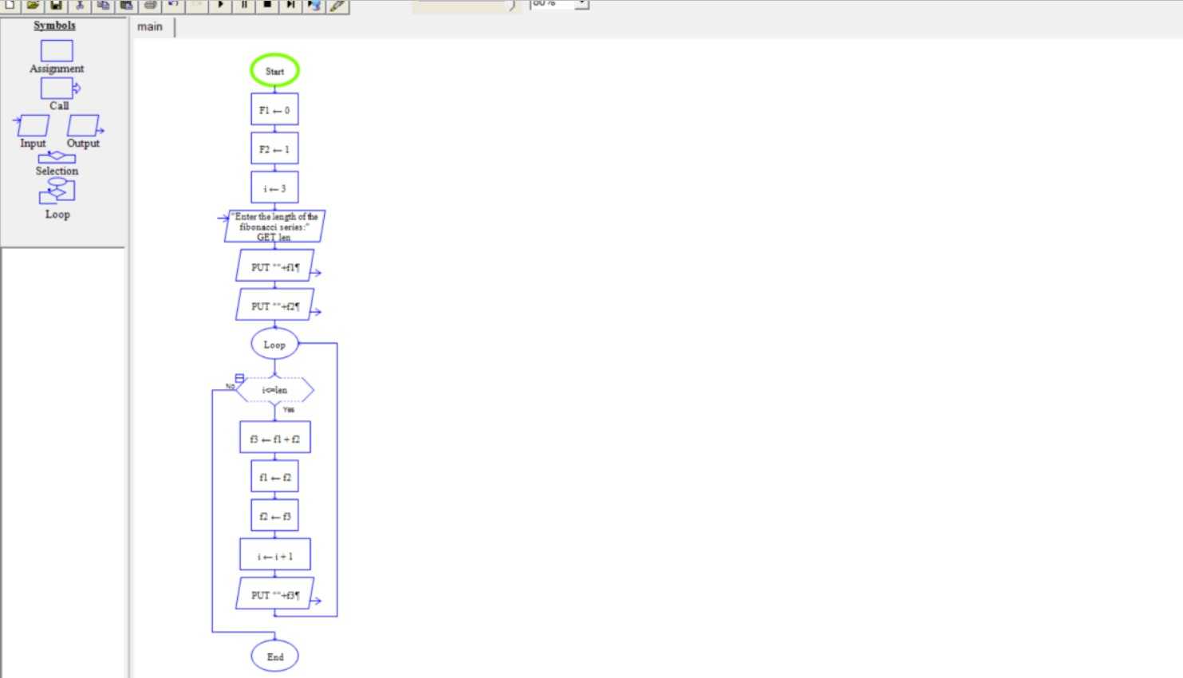

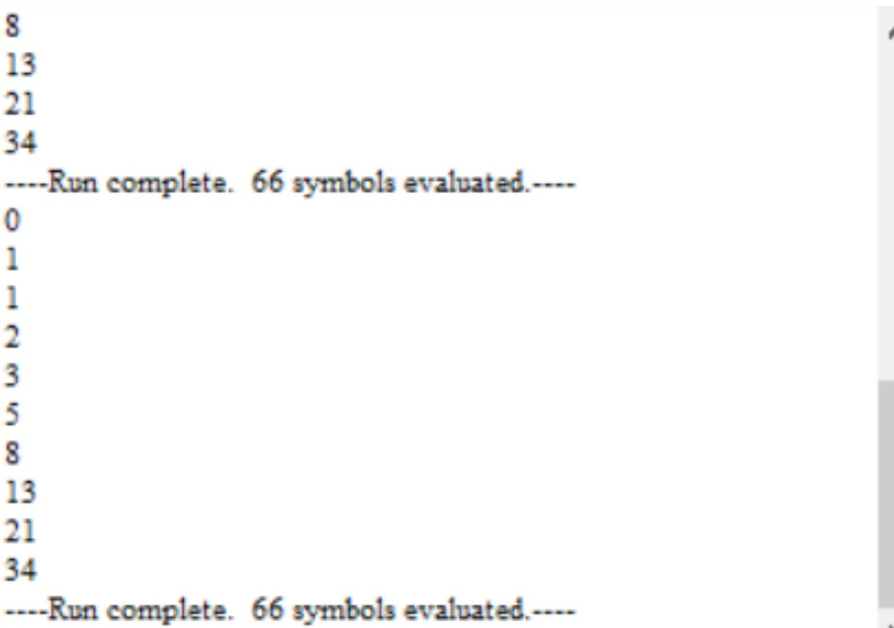

36.UsingRaptor–Drawtheflowcharttofindsmallestofnnumbers

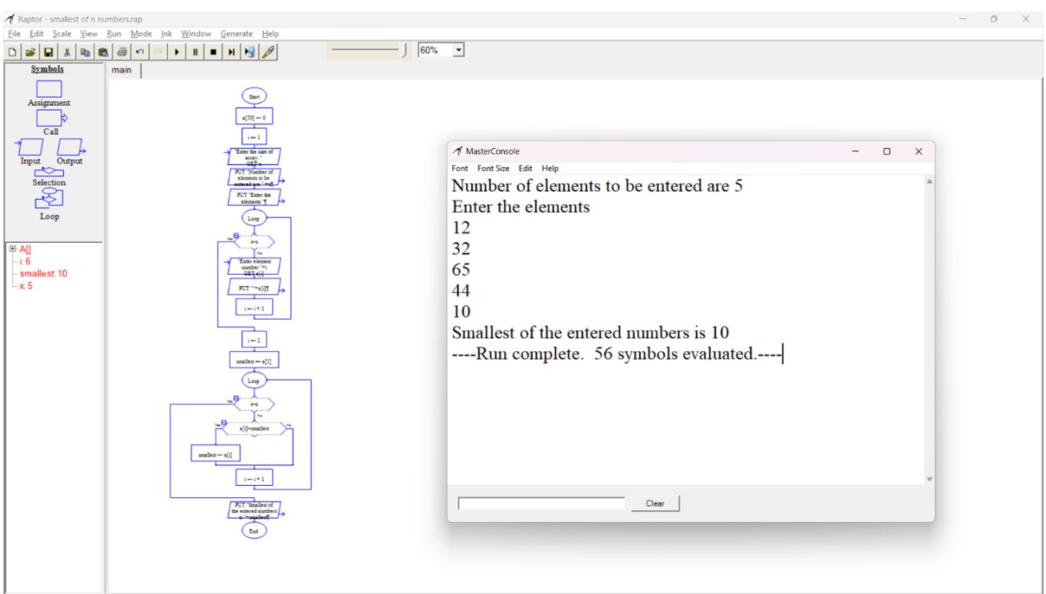

37.EWalletManagementSystem(EMS)usingUsecasediagram

3

8

.

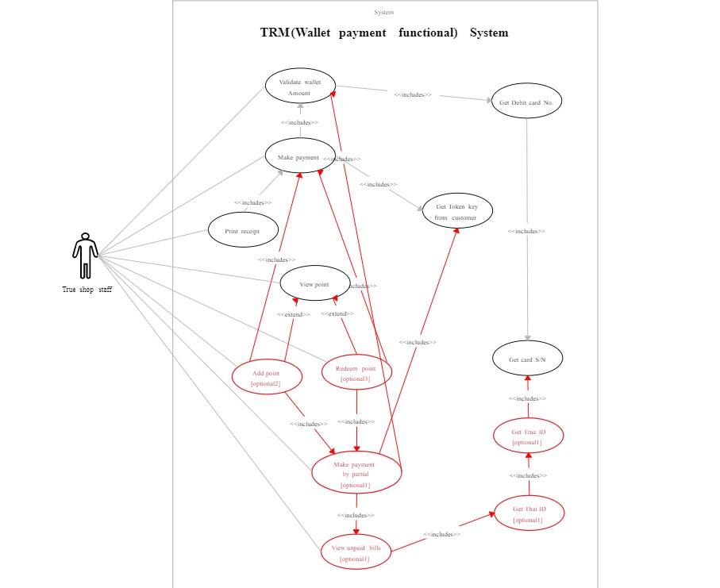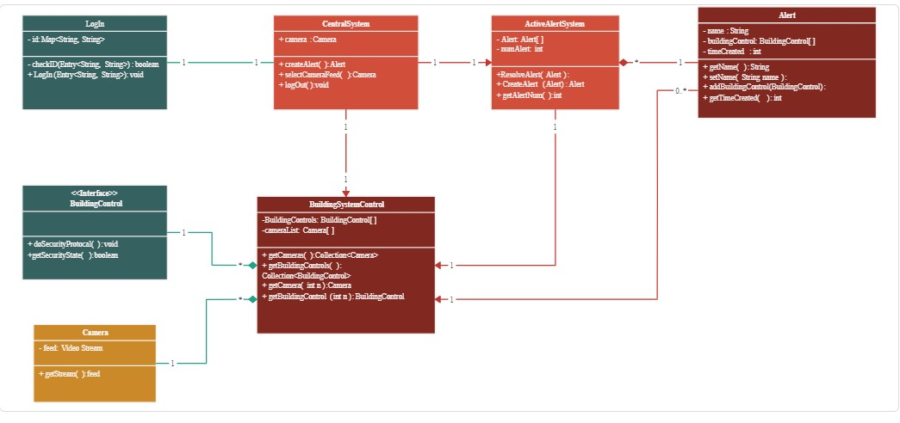

Onlinesecuritymanagementsystemusingclassdiagram

39.usecasediagramforonlinevoting



40.ConstructaflowchartusingraptorandCheckwhetherastringis palindromeornot

